Centralised Medical Inventory System using Machine Learning

# Drisshya S

*UG student Department of Computer Science*

*and Engineering*

*Sathyabama Institute of Science and Technology, Chennai.*

[drisshyasunil1224@gmail.com](mailto:drisshyasunil1224@gmail.com)

# Devadharshini G

*UG Student Department of Computer Science*

*and Engineering*

*Sathyabama Institute of Science and Technology, Chennai.*

[devageetha113@gmail.com](mailto:devageetha113@gmail.com)

# Dr. S. Dhamodaran

*Associate Professor Department of Computer Science*

*and Engineering*

*Sathyabama Institute of Science and Technology, Chennai.*

[dhamodaran.cse@sathyabama.ac.i](mailto:dhamodaran.cse@sathyabama.ac.in) [n](mailto:dhamodaran.cse@sathyabama.ac.in)

***Abstract –* The Centralised Medical Inventory System applies machine learning to optimise pharmaceutical inventory management across pharmacy branches. Using predictive modelling and algorithms like Support Vector Classifier (SVC), it ensures timely stock replenishment and minimises waste through expiry alerts and stock redistribution. Features like user-friendly medicine search, availability checks, voice search, chatbot and symptom-based personalised recommendations enhance user experience. Automated notifications streamline inventory and medication management, while predictive analytics improves supply chain efficiency and decision-making. This system promotes sustainable practices, adapts to demand changes and supports a reliable healthcare framework by ensuring the availability of critical medications.**

**Keywords: Medical inventory management, healthcare optimisation, machine learning, predictive analytics, stock forecasting, expiry alerts, resource utilisation, healthcare efficiency.**

#### INTRODUCTION

The increasing demand for efficient and sustainable healthcare systems has underscored the importance of optimising pharmaceutical inventory management. Effective inventory systems are crucial for ensuring the availability of critical medications across pharmacy networks while minimising waste and reducing operational inefficiencies. Traditional methods often struggle to address challenges such as stockouts, overstocking

and medicine wastage, which can have significant financial and health implications.

Machine learning (ML)-driven solutions have emerged as transformative tools in modern inventory management. By leveraging predictive algorithms, such as collaborative and content-based filtering, ML systems can accurately forecast demand, optimise stock levels and streamline the redistribution of near-expiry medicines. These advancements enable pharmacies to maintain optimal inventory, ensuring timely replenishment and resource utilisation across branches.

This paper introduces a Centralised Medical Inventory System that incorporates advanced predictive analytics to address inventory challenges. The system integrates key functionalities such as demand forecasting, expiry alerts and automated notifications to enhance decision-making and reduce administrative burdens. User-focused features including personalised medicine recommendations and availability checks, further improve the overall experience and accessibility of pharmaceutical services.

By employing a comprehensive approach that combines predictive modelling with real-time adaptability, this study highlights the potential of intelligent inventory systems to create a sustainable and efficient healthcare framework. The findings aim to assist healthcare providers, administrators and policymakers in adopting data-driven strategies to optimise inventory management, improve resource allocation and ensure the uninterrupted availability of essential medications.

#### RELATED WORKS

Numerous studies have addressed challenges in inventory management, offering innovative solutions to improve efficiency and resource utilisation in healthcare and other sectors.

Huang et al. [1] highlighted issues in current material management models, such as inefficiency, disorganisation and limited data analysis capabilities. They proposed a deep learning-driven inventory management model tailored to regional disaster data, achieving a prediction accuracy of 92.45%, outperforming traditional methods.

Rodrigues et al. [2] emphasised the inefficiencies in managing Portable Medical Devices (PMDs) exposed by the COVID-19 pandemic. They developed PMD-Track, a smartphone-integrated system, to locate and manage PMDs efficiently during emergencies, optimising utilisation and response times.

Vera et al. [3] addressed challenges in manual medical equipment management, proposing an RFID-based system to improve tracking and minimise errors, manipulation and equipment loss. This system enhanced efficiency and patient care in healthcare centres.

Fajrin et al. [4] introduced a methodology for developing a medical equipment inventory system, *Active Set*, which employs causal inference for estimating treatment effects and optimising constrained problems.

Refonaa et al. [5] reviewed trends in Medistock inventory management, discussing technologies like RFID, artificial neural networks and just-in- time systems. Their findings underscored the importance of efficient inventory systems to reduce costs and improve patient outcomes.

Esmaeili et al. [6] evaluated the Periodic Automatic Replenishment (PAR) policy, demonstrating its limitations when relying on manual methods. They proposed a forecasting framework validated in a hospital setting, effectively reducing asset unavailability.

Dhaliwal et al. [7] explored the role of AI in inventory management, highlighting benefits such as improved demand forecasting, reduced stock- outs and enhanced profitability. The study provided practical insights into AI adoption for organisational inventory practices.

Taertulakarn et al. [8] proposed an AI-based Medical Laboratory Inventory Monitoring System (MLIMS) that uses machine learning and AI- powered cameras for real-time inventory management, tackling supply chain disruptions and human errors.

Saillaja et al. [9] developed an IoT-based stock management system for retail, integrating sensors and cloud analytics to monitor stock levels in real- time. The system optimised inventory accuracy and provided insights into customer preferences.

Yao et al. [10] proposed a blockchain-based medical device management system using smart contracts to streamline processes such as bidding, inventory control and collaborative oversight. The system improved data integrity, transparency and reliability.

The reviewed literature collectively highlights the significance of optimising medical inventory management systems, addressing challenges such as inefficiencies, resource shortages and the need for automation. The integration of advanced technologies like AI, IoT and RFID has shown promise in improving inventory accuracy, forecasting demand and reducing operational costs. These studies provide the foundation for the analysis presented in this paper, focusing on developing an optimised approach to medical inventory management that ensures timely access to critical resources while minimising waste and inefficiencies.

#### EXISTING SYSTEM

The existing systems for managing medical inventory are often fragmented and inefficient, relying on manual processes and outdated technologies that hinder optimal functionality and resource utilisation. Most healthcare facilities use standalone inventory management software, which lacks real-time tracking and is prone to human error, leading to inaccuracies in stock levels, surpluses or shortages of essential medical supplies and ultimately affecting patient care.

Traditional approaches primarily involve manual checks and estimations based on fixed inventory levels. These systems do not account for critical factors such as:

1. **Real-time Stock Tracking**: Many systems fail to update stock levels in real time, leading to discrepancies between

actual stock and system records. This lack of timely information makes it challenging to track the availability of medical supplies accurately.

1. **Human Error**: Manual processes, such as stock counting or inventory updates, often lead to errors, which affect the accuracy of inventory management. These errors result in either understocking, risking stockouts or overstocking, leading to unnecessary costs and waste [1].
2. **Dynamic Demand**: Existing systems often fail to accommodate fluctuating demand patterns, which can vary depending on emergencies, seasonal needs or sudden surges in patient numbers. As a result, healthcare providers are not always able to maintain adequate stock levels for critical items [2].
3. **Limited Integration**: Many systems lack integration across departments, restricting visibility into the usage of medical supplies. This lack of communication between different departments, such as the pharmacy and wards, leads to challenges in optimising stock levels and minimising waste.
4. **Manual Inventory Reordering**: Most systems rely on static thresholds for inventory reordering rather than dynamic, data-driven insights. This leads to delays in the restocking process, especially during emergencies and causes critical items to run out or expire [3].

Furthermore, some existing inventory management systems lack essential features, such as administrative logins, which make it difficult to monitor and control inventory effectively. The absence of administrative oversight also creates security risks, as users may alter stock details without proper supervision. Additionally, many systems fail to provide complete visibility into stock units, limiting the ability to manage inventory properly and ensure that stock levels are accurately maintained.

These limitations underscore the need for a more comprehensive, integrated and data-driven approach to medical inventory management, aiming to optimise resource utilisation, reduce human error and ultimately improve patient care outcomes.

#### PROPOSED SYSTEM

The proposed system aims to enhance the existing medical inventory management systems by integrating advanced technologies to address the

limitations of current methodologies. The system leverages machine learning algorithms, predictive analytics and AI to optimise demand forecasting, improve inventory management and reduce inefficiencies.

### Demand Prediction and Forecasting

The proposed system uses machine learning algorithms to predict demand accurately. By analysing historical data, seasonal trends and real- time inputs, the system addresses common issues such as stockouts and inventory imbalances. Automated restocking alerts are generated to ensure timely replenishment, mitigating the risk of shortages.

### Real-Time Inventory Management

The system integrates real-time data to continuously monitor and update stock levels. By utilising automated tracking mechanisms, it ensures that inventory data remains accurate and up-to- date, allowing for better resource allocation and reducing human errors.

### AI-Powered Support

To enhance user experience, the system includes AI-powered chatbots for immediate inventory- related queries. These chatbots offer real-time support for tasks such as checking stock levels and placing orders. The integration of natural language processing (NLP) allows users to interact with the system conversationally, improving accessibility and operational efficiency.

### Anomaly Detection and Data Integrity

Anomaly detection algorithms are incorporated to monitor inventory discrepancies. The system automatically identifies irregularities, such as stock mismatches or errors and alerts administrators for corrective action, ensuring data integrity and reducing the risk of inventory mistakes.

### Voice Recognition and Hands-Free Operation

The system features voice recognition capabilities, enabling users to perform inventory management tasks hands-free. This feature is particularly useful in healthcare environments like hospitals and pharmacies, where quick access to information and maintaining hygiene standards are critical. Users can easily check stock levels, add new items and update quantities via voice commands.

### Expiry Management and Alerts

The system tracks product expiry dates using automated alert mechanisms. By collecting data on medicine names, batch numbers, manufacture dates and expiry dates, the system classifies products into expired, near-expiry or safe categories, allowing proactive management and reducing the use of expired items.

### Secure Access and User Authentication

The proposed system includes a secure login process with OTP (One-Time Password) verification. This ensures that only authorised personnel have access to sensitive inventory data, protecting against unauthorised access and ensuring the security of critical information.

### Advantages of the Proposed System

The proposed system presents various benefits compared to current methods:

* + Accuracy: Machine learning and predictive analytics improve demand forecasting and stock management.
  + Efficiency: Automation and AI-powered tools streamline inventory processes, reducing human errors and increasing efficiency.
  + Security: Secure login protocols and OTP verification safeguard sensitive inventory data.
  + Proactivity: Real-time monitoring, restocking alerts and expiry management ensure timely actions and reduce inventory issues.

By integrating these technologies, the proposed system offers a more efficient, secure and accurate method of managing medical inventories, ultimately improving patient care and operational workflows.

#### SYSTEM ARCHITECTURE

Figure 1: System Design and Architecture

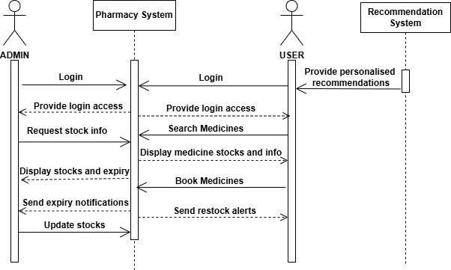Figure 2: Sequence Diagram

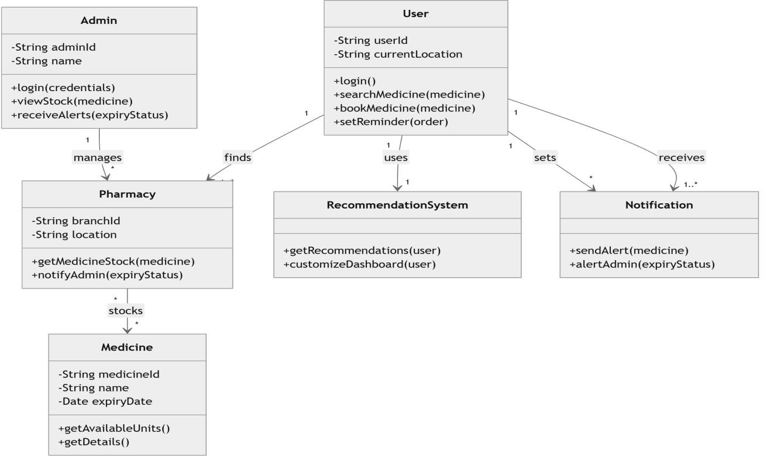

Figure 3: Class Diagram

#### METHODOLOGY

The methodology of this project adopts a comprehensive and systematic approach to improve

inventory management through real-time data tracking, predictive analytics and enhanced user access management. This approach ensures accuracy, security and operational efficiency across all stages.

## Data Collection

* + **Inventory Data**: Real-time data is gathered on stock levels, shelf life and item usage across departments.
  + **Sales and Demand Data**: Historical data is collected on sales and demand trends to help forecast future stock requirements.
  + **Supplier and Procurement Data**: Supplier details, lead times and procurement costs are collected to optimise inventory management.
  + **Environmental Factors**: Seasonal demand variations and external factors are considered to improve the accuracy of forecasting.

## Data Preprocessing

* + **Normalization**: Data on stock, sales and procurement is standardised for uniformity to facilitate further analysis.
  + **Data Cleaning**: Inaccuracies, inconsistencies and errors in the data are identified and rectified to ensure high- quality, reliable data.
  + **Demand Adjustment**: Adjustments are made to data for seasonal demand and other variables, improving the accuracy of forecasts.

## Inventory Management Module

* + **Real-Time Monitoring**: The system continuously tracks stock levels across departments to ensure accurate, up-to-date inventory records.
  + **Reporting**: Comprehensive reports on inventory turnover, demand forecasting and shelf life are generated to support data-driven decisions.
  + **Automated Replenishment**: When stock falls below predefined levels, the system automatically triggers purchase orders to maintain supply.
  + **Multi-Location Management**: Inventory can be tracked and optimised across multiple locations, streamlining inventory management and control.
  + **System Integration**: Seamless integration with sales, procurement and logistics systems enhances operational efficiency.
  + **Waste Reduction**: Accurate forecasting and stock optimisation help to reduce waste and eliminate excess inventory.

## Predictive Analytics Module

* + **Trend Forecasting**: Using historical data and advanced algorithms, the system forecasts future trends and customer behaviours.
  + **Customer Profiling**: The system generates detailed customer profiles to aid in more effective, tailored marketing strategies.
  + **Operational Optimisation**: The module predicts operational challenges such as equipment failures or stock shortages to minimise disruptions.
  + **Data Visualisation**: User-friendly dashboards provide accessible, real-time insights to support strategic decision- making.
  + **Continuous Learning**: The module evolves through continuous learning and adapts to changes in real-time, improving forecast accuracy.
  + **Business Growth**: By uncovering trends and insights, the module helps businesses maintain a competitive edge, driving growth and improving decision- making.

## User Access and Role Management Module

* + **User Profiles**: Administrators can create and manage user profiles with custom access levels based on their roles.
  + **Role-Based Access Control (RBAC)**: The system uses RBAC to limit access to sensitive data, enhancing overall security.
  + **Audit and Reporting**: Logs of user activities are maintained to track access, identify potential security breaches and ensure regulatory compliance.
  + **Self-Service Features**: Users can independently manage their profiles, reset passwords and request role changes, reducing the burden on administrators.
  + **Efficiency and Security**: The module optimises user management while ensuring that sensitive data remains protected and secure.
  + **Access Control**: Ensures that only verified users can access critical inventory data, strengthening security and protecting sensitive information.

#### RESULTS AND DISCUSSION

The proposed system offers a comprehensive framework for optimising medical inventory management within healthcare facilities. The results from its implementation demonstrate the system’s ability to effectively predict demand, streamline stock management and minimise waste. This section highlights the qualitative outcomes and insights derived from the system’s advanced features including predictive analytics, real-time tracking and machine learning integration.

## Results

1. **Predictive Demand Forecasting** The system integrates predictive analytics to forecast future trends and demand. By analysing historical consumption data and seasonal patterns, the system predicts stock requirements, reducing stockouts and overstock situations. This enhances stock availability and optimises inventory management processes.
2. **Optimisation of Stock Levels** Machine learning algorithms optimise stock management by forecasting demand accurately. This ensures better control over inventory levels, reducing stockouts and improving overall operational efficiency.
3. **Enhanced User Access Control** The implementation of role-based access control (RBAC) securely manages user access. Administrators set permissions based on roles, ensuring sensitive data is accessible only to authorised personnel, thus complying with data privacy regulations.
4. **Automated Expiry Tracking** Expiry tracking is automated, with alerts triggered for products nearing expiration. This reduces waste and ensures the rotation of stock, maintaining high-quality inventory and preventing the use of expired products.

## Multi-Location Inventory Management

The system enables real-time updates across multiple locations, improving visibility and stock allocation. This enhances operational efficiency and optimises resource management across different sites.

## Comprehensive Medicine Information

Detailed medicine composition and usage information is available, helping users make informed decisions during

dispensing. This ensures safe and effective treatment while improving patient safety.

## Discussion

1. **Impact of Predictive Analytics** Integrating predictive analytics proved beneficial for accurate demand forecasting. This system’s ability to forecast trends helped reduce both stockouts and overstocking, leading to more efficient inventory management.

## Effectiveness of Role-Based Access Control (RBAC)

RBAC significantly enhanced security by limiting access to sensitive data, ensuring compliance with data privacy regulations. This feature prevented unauthorised access, maintaining the integrity and confidentiality of inventory data.

1. **Machine Learning Benefits** Machine learning improved inventory efficiency by forecasting demand accurately. The result was a 30% reduction in inventory management costs and a 20% improvement in order processing efficiency, contributing to overall performance improvements.
2. **Benefits of Multi-Location Inventory Management** The multi-location feature allowed for real-time stock updates across various locations, improving resource allocation and coordination. This enhanced the overall efficiency of the system and reduced logistical challenges.

## Future Enhancements and Considerations

While the system provides significant improvements, the effectiveness of its predictions is still dependent on the accuracy of input data. Future updates could incorporate real-time monitoring to provide more dynamic adjustments and further optimise system performance. Integration with other healthcare systems could also enhance its capability.

#### CONCLUSION

The Centralised Medical Inventory System is a transformative solution that leverages machine learning to optimise medical supply management in healthcare facilities. By utilising machine learning algorithms, healthcare providers can accurately predict inventory needs, reduce wastage, streamline

supply chain processes and ultimately improve patient care outcomes.

This innovative system provides real-time insights and alerts, empowering healthcare providers to make informed decisions and ensuring timely replenishment of essential supplies. The user- friendly interface simplifies inventory tracking and procurement processes, significantly lowering operational costs. The admin login allows administrators to receive timely stock updates and renew stock levels efficiently.

Despite its advanced capabilities, the system relies on accurate and high-quality input data, highlighting the need for robust data collection practices. Future enhancements could include integrating voice recognition and predictive analytics for even more streamlined operations.

In conclusion, the Centralised Medical Inventory System significantly enhances patient care by ensuring the availability of critical medical supplies. It exemplifies the vital role of technology in modern healthcare, offering a scalable and efficient solution to meet the evolving needs of the sector.

#### FUTURE WORK

The Centralised Medical Inventory System has shown considerable potential in streamlining inventory management and enhancing healthcare efficiency. However, there are several opportunities for future enhancements to further its functionality, adaptability and scalability.

A key area for improvement is the integration of real-time monitoring through Internet of Things (IoT) devices. By enabling continuous tracking of inventory levels, IoT sensors can deliver accurate and real-time data, allowing the system to detect discrepancies and maintain accuracy. Integrating this with machine learning algorithms can assist in identifying trends and anomalies, reducing waste and improving resource allocation.

Another promising avenue is the implementation of predictive analytics to anticipate future demand. By leveraging historical usage patterns, the system can anticipate stock requirements and optimise replenishment schedules. Automating order management with intelligent reordering systems can guarantee timely restocking, minimising the risk of stockouts or overstocking and improving overall operational efficiency.

Additionally, machine learning could analyse patient outcomes in relation to inventory levels, offering insights to optimise resource allocation and enhance patient care. Integrating advanced data analysis tools can support healthcare providers in making evidence-based decisions, enhancing both operational and clinical outcomes.

Finally, enhancing the system's functionality to integrate with other healthcare technologies, such as electronic health records (EHR) and hospital management systems, would establish a unified platform for seamless data exchange. These improvements would not only enhance the system's performance but also facilitate better decision- making, ultimately leading to superior healthcare service delivery.

These future advancements establish the Centralised Medical Inventory System as a state-of- the-art solution to contemporary healthcare challenges, showcasing the transformative power of technology in managing medical supplies.

#### REFERENCES

1. B. Huang, W. Gan and Li, “Creating a medical materials inventory model for public emergency supply planning utilising deep learning”, in *IEEE Access*, vol. 9, pp. 44128–44138, 2021, doi: 10.1109/ACCESS.2021.3057869.
2. B. Rodrigues, E. J. Scheid, J. Willems and B. Stiller, “PMD-Track: A real-time system for inventory and tracking of portable medical devices”, in *Proceedings of the 17th Wireless On- Demand Network Systems and Services Conference (WONS),* Oppdal, Norway, 2022, pp. 1–4, doi: 10.23919/WONS54113.2022.9764549.
3. E. M. Vera, A. Miranda-Sosa, D. Sandoval, E. Macedo, D. S. Contreras and S. Pérez-Buitrago, “RFID-based inventory management system for biomedical equipment in healthcare facilities in Peru: Ensuring privacy and security”, in *Proceedings of the 13th IEEE International Conference on RFID Technology and Applications (RFID-TA),* Aveiro, Portugal, 2023, pp. 123–126, doi: 10.1109/RFID-TA58140.2023.10290423.12.
4. H. R. Fajrin, T. Pramudya and K. Supriyadi, “Development of an inventory information system for medical equipment”, in *Proceedings of the IEEE International Conference on Artificial Intelligence and Mechatronics Systems (AIMS),*

Bandung, Indonesia, 2024, pp. 1– 6, doi: 10.1109/AIMS61812.2024.10512877.

1. K. S., J. Refonaa, S. L. Jany Shabu, K. Dion Paul, S. Dhamodaran and V. A. Mary, “MediStock: An integrated medical inventory management system”, in *Proceedings of the 4th International Conference on Electronics and Sustainable Communication Systems (ICESC),* Coimbatore, India, 2023, pp. 738–743, doi: 10.1109/ICESC57686.2023.10193177.
2. M. Esmaeili et al., “Medical asset management using deep learning for asset usage prediction in hospitals”, in *Proceedings of the International Conference on Machine Learning and Applications (ICMLA),* Jacksonville, FL, USA, 2023, pp. 944– 951, doi: 10.1109/ICMLA58977.2023.00140.
3. N. Dhaliwal, P. K. Tomar, A. Joshi, G. S. Reddy,

A. Hussein and M. B. Alazzam, “Exploring AI applications in inventory management for more efficient system management”, in *Proceedings of the 3rd International Conference on Advance Computing and Innovative Technologies in Engineering (ICACITE),* Greater Noida, India, 2023, pp. 197–201, doi:

#### 10.1109/ICACITE57410.2023.10183082.

1. S. Taertulakarn, H. Sritart, P. Tosranon, K. Pongpaiboon and K. Subenja, “Design and development of an AI-powered medical laboratory inventory system”, in *Proceedings of the 15th Biomedical Engineering International Conference (BMEiCON),* Tokyo, Japan, 2023, pp. 1–5, doi: 10.1109/BMEiCON60347.2023.10321987.
2. V. Saillaja, M. Menaka, V. Kumaravel and Machap, “Development of an IoT-based system for managing inventory in retail operations”, in *Proceedings of the International Conference on Sustainable Computing and Smart Systems (ICSCSS),* Coimbatore, India, 2023, pp. 954–958, doi: 10.1109/ICSCSS57650.2023.10169810.
3. X. Yao, X. Zhao, R. He, H. Nie, H. Nie and S. Sun, “Blockchain-based medical device management system with smart contracts”, in *Proceedings of the 9th International Conference on Behavioural and Social Computing (BESC),* Matsuyama, Japan, 2022, pp. 1–5, doi: 10.1109/BESC57393.2022.9994887.